In addition to the growth in new technology, the design process in industry has also experienced significant change in recent years. Model-Based Design is now commonly used in automotive, aeronautical, and other industries for complex embedded systems. Traditional design workflow follows a sequential path that involves: a) Requirements, b) Design, c) Implementation, and d) Test and validation. Problems with traditional design can develop when: 1) specifications must be read and understood by different engineers on different teams, 2) application engineers have to rewrite design engineers’ algorithms, or 3) the problem is not found until the testing phase.

Model-Based Design uses models early in the process to create executable specifications that allow engineers to immediately validate and verify specifications against the requirements. Engineers then share models that can demonstrate the performance of the subsystems and components, and also use the automatic code generation capability of Simulink/Real Time and Embedded Coder to facilitate Hardware-In-The Loop (HIL) testing.

The model development process consists of 1) determining how the model will be used, 2) identifying the key equations, parameters, and assumptions, 3) building and refining the model, and then 4) the actual model application and evaluation.

Simulation is a key tool that facilitates design while reducing the cost of product development. As the design process evolves engineers can perform Model-In-The-Loop (MIL), Software-In-The-Loop (SIL), and Hardware-In-The-Loop (HIL) development modeling model is the design. By integrating simulation within the design process engineers can decrease both design costs and design time thus enabling companies to complete and test designed items.

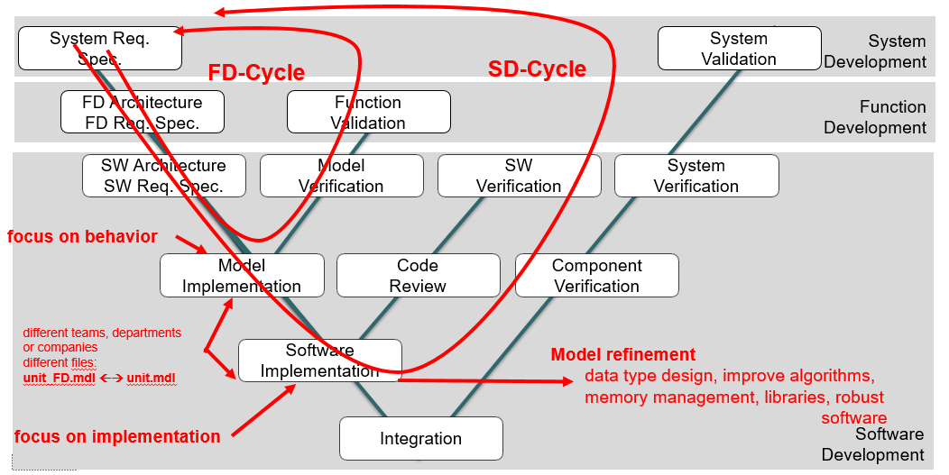

V-Mode Development Process (Function and Software Development)

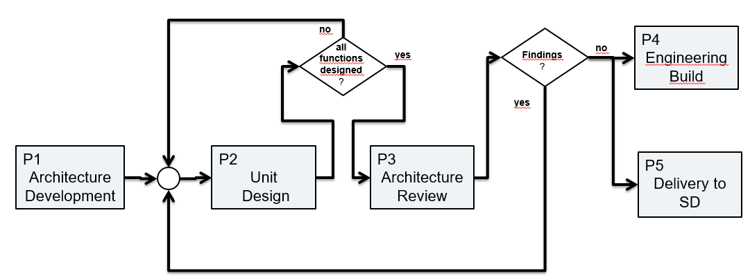

Function Development Process Overview

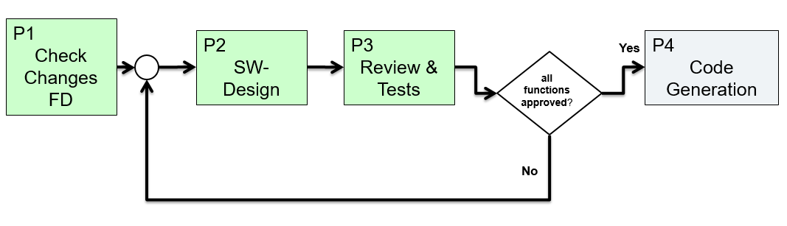

After FD Process Overview

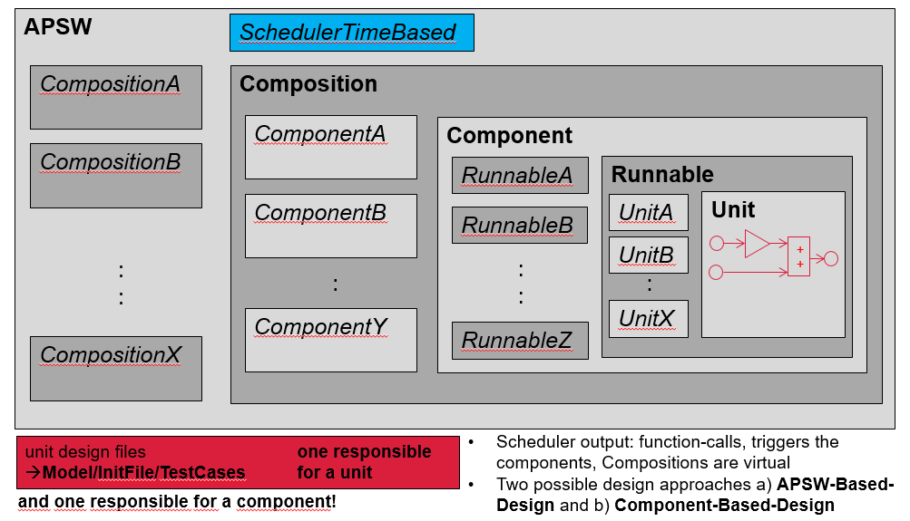

APSW Development

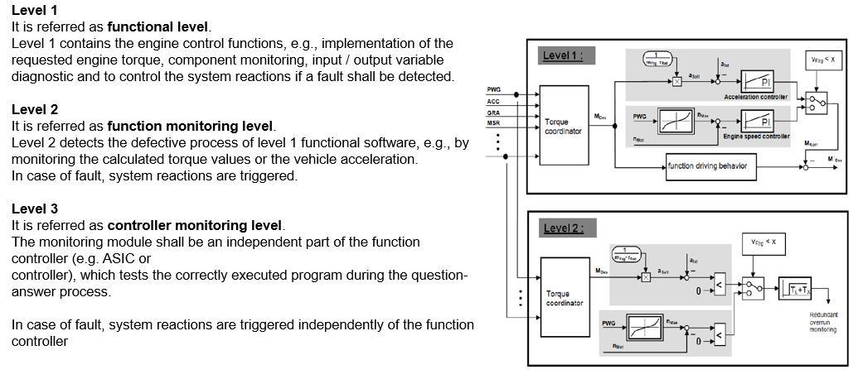

Software Levels

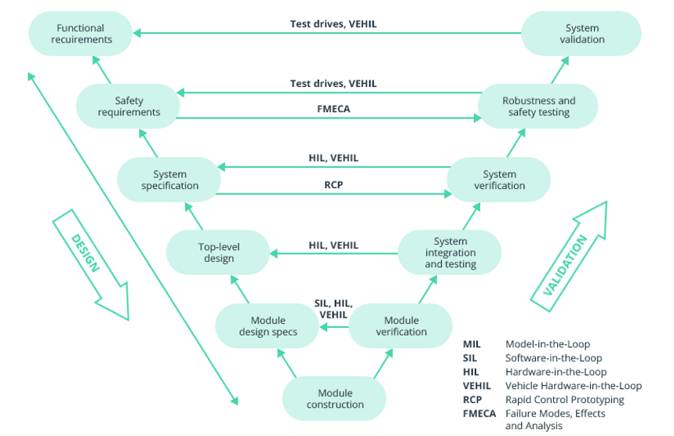

Design and Validation

1. **Model-in-the-Loop (MIL):**

* Controller Model – Plant Model Interaction
* Both are created and designed in MATLAB/Simulink
* Verification is done to decide if the plant can be controlled by the controller
* Log I/O data to register how the system behaves

1. **Software-in-the-Loop (SIL):**

* C Code Generated from the Controller Model – Plant Model Interaction
* Run the simulation and log the I/O data to compare the behavior with the MIL results
* If there is any difference, repeat this or the previous step

1. **Processor-in-the-Loop (PIL):**

* C code generated from the controller model is on an embedded processor or an FPGA
* Embedded Processor – Plant Model Interaction
* Run the simulation and log I/O data to compare the behavior with the SIL results
* If there is any difference, repeat this or the previous steps

1. **Hardware-in-the-Loop (PIL):**

* C code generated from the controller model is on an embedded processor or an FPGA
* The plant model is replaced with the actual hardware
* Controller on an Embedded Processor – Plant Hardware Interaction
* Run the simulation and log I/O data to compare the behavior with the PIL results
* This allows us to run tests which would be hazardous, costly and not easily feasible on real plants (also extensive testing improves performance)
* If there is any difference, repeat this or the previous steps

In order to improve the efficiency and reduce the cost, the automobile electronic system proposed the V-Mode development process, including function design and Simulink simulation, rapid prototyping development, automatic code generation of products, hardware-in-the-loop test and real vehicle calibration, so that every step of the development process can be verified.

HIL test system can be divided into three levels, namely the signal level, power level and machine level.

The specific features of a HIL test system based on NI-PXI platform (cheap and easy integration) can be as follows:

(1) Use external board through a specific response input and output to simulate the input and output of VCU.

(2) Use Veristand to develop the host computer interface, configure the hardware interface, and manage NI hardware resources.

(3) With the fault system, the physical channel of the board and the VCU to be tested are connected to realize the fault simulation function.

(4) The vehicle model built by MATLAB/Simulink runs in the NI real-time system, in order to simulate the vehicle running environment and realize the hardware-in-loop-test.

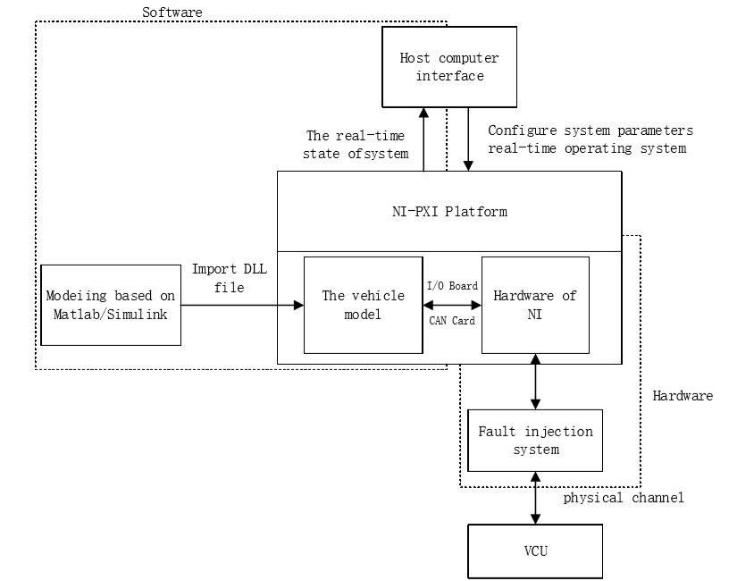

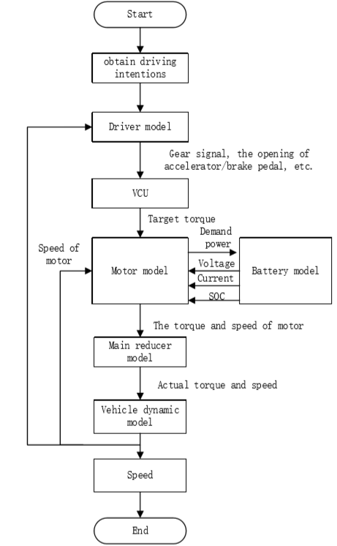

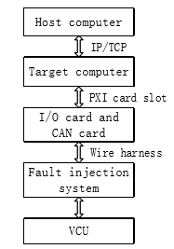

**Battery Model:** The inputs of this module are the demand power returned by the motor model and other parameters, and its outputs are actual output power, output voltage, working current and SOC (state of charge). The positive power represents discharge, and the negative power represents charge. The battery model is built on Thevenin model with first-order RC circuit.

The output voltage of the battery model is limited by the SOC and the maximum output power. When the value of SOC close to 100%, the charging power is 0, and when the value is close to 0, the discharging power is 0.

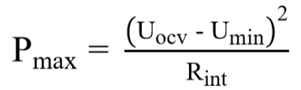In addition, the maximum output power is related to open circuit voltage U**ocv**, the minimum operating voltage U**min**, and the internal resistance R**int**.

SOC is the ratio of the residual capacity to the total capacity. The value of SOC can be estimated by using ampere-hour method.

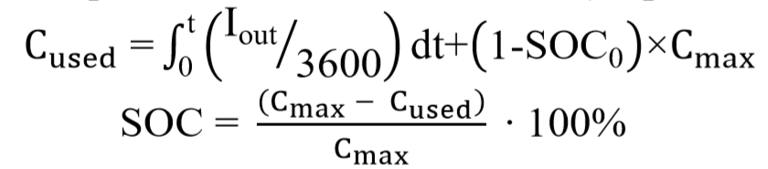

**Motor Model:** The main inputs of the motor model include output voltage (U) and provided power from the battery model, and the model also receives the target torque sent by VCU through CAN and the actual speed (n) of motor from the vehicle dynamics model.

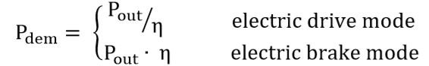The maximum output torque of the motor can be obtained according to the current speed of the motor by table lookup, and then comparing the maximum output torque and the target torque, the value of motor’s output torque (T) is the minimum when the torque is positive or the maximum when the torque is negative. We can look up the MAP figure to get the efficiency (η) with the current speed and torque of the motor, other parameters such as the output power (P**out**), the demand power (P**dem**) and output current can be calculated.



**Main Reducer Module:** If the demand power is greater than the maximum working power of the motor, in order to protect the motor, it is necessary to add a power limit module to limit the demand power so that the working power of the motor will not exceed the maximum working power.

The function of the main reducer module is to reduce speed and increase torque, its inputs are the speed (In**speed**) and torque (In**torque**) from motor, and the module output the actual speed (Out**speed**) and torque (Out**torque**) after calculating with the transmission ratio (T**ratio**) and transmission efficiency of the main reducer.

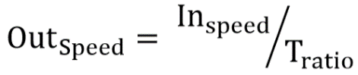



**Vehicle Dynamic Model:** The vehicle dynamic model can obtain the actual speed of the vehicle on the basis of the longitudinal dynamic equation, and then send the speed to the driver module to form a closed-loop test. According to the relevant knowledge of automobile theory, traction (F**t**) is the sum of rolling resistance (F**f**), air resistance (F**w**), slope resistance (F**i**) and acceleration resistance (F**j**). The vehicle speed can be obtained by expanding this equation.

**Cycle Condition Model and Driver Model:** The main function of the driver model in the manual test mode is to simulate the vehicle power logic and analyze the driving intention, including the analysis of the gear signal and accelerator / brake pedal signal, and then send the analytical physical signal to VCU. In the automatic test mode, introducing the PID controller to find the position of the accelerator / brake pedal according to comparing the different speed curves from the cycle condition model and the actual speed sent by the vehicle dynamic model, so that these two module can achieve the test of simulating different cycles conditions.

Veristand is a data calibration software developed by National Instrument (NI) specifically for HIL test system.

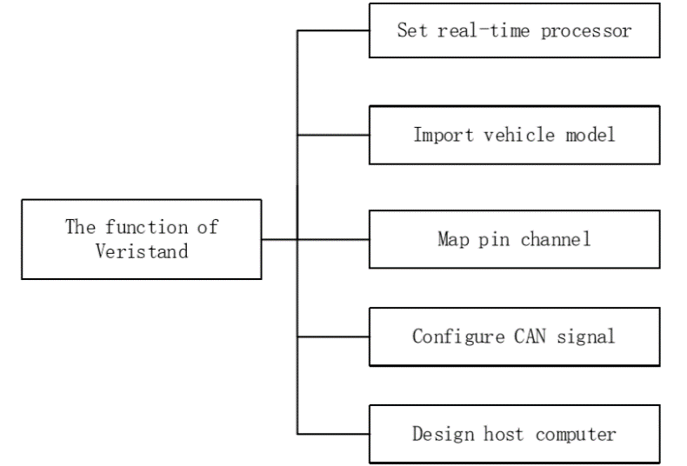

**Vehicle Model Design Tips:** The vehicle model of traditional HIL test system is customized for a certain vehicle, so the model needs to be modified first if the test object had changed, and the DLL file should be generate again, resulting in the workload of reuse the system becomes much larger. In order to solve the problem, the object-oriented programming idea is introduced creatively in the design of the model, and the approach practice is to design a table of parameter, which contains the detailed parameter information of the vehicle, motor and battery.

The relevant information can be read and used from the table when the model runs, and this is a good way to avoid repeated and boring modifications to the model when it comes to experiments on different vehicles, the users just need to refill the table of parameter, and then the only thing needs to do is compile and run. Much time and human resources can be saved in this way. Besides, the risk of making mistakes when modifying the model will be reduced.

The HIL test system can simulate the vehicle logic power and the process of acceleration and deceleration.

The fault test mainly simulates the working state of VCU in the process of vehicle simulation, and the test of cycle condition is mainly to test the driving range and energy consumption.

**Driving Cycle:** A driving cycle is a set of second-by-second set of vehicle velocity values that the simulated vehicle is to attain during the simulation. The need of a drive cycle is to reduce the quantity of expensive on-road tests, and also reduce both the time of test and fatigue of the test engineer. The drive cycle process brings the road to the dynamometer or to the computer simulation.

Drive cycles are used in vehicle simulations to model the drive system and predict the performance of the drive system. There are many standard driving cycles used for testing road vehicles for fuel economy and other purposes. Some driving cycles are developed theoretically, and others are direct measurements of a representative driving pattern. A driving cycle can include frequent speed changes or extended periods at constant speed. An example of vehicle simulator is ADVISOR produced by AVL Engineering and other on-line road load and fuel economy simulations.

The drive train consumes energy from the battery during motoring. The drive train can also add charge to the battery if the motor is operated as a generator during regeneration. This can occur during braking or if the vehicle is being powered by an Internal Combustion Engine (ICE). The battery is frequently constructed of Lithium Ion cells, and supplies 300+ volts and high current to the power electronics. A battery controller monitors key battery parameters and controls the battery pack.

The power electronics unit inverts the DC battery voltage into three-phase AC voltage at the proper frequency and voltage for the motor to meet the requested speed and torque. The AC motor is typically a high efficiency AC Induction Motor (IM) or Permanent Magnet Synchronous Motor (PMSM). These motors can supply either acceleration torque or braking torque for both directions of rotation. When the vehicle’s brakes are applied the motor operates in regeneration mode thus reversing both the current direction and torque direction. The reversed torque direction provides vehicle braking torque while helping to recharge the battery.

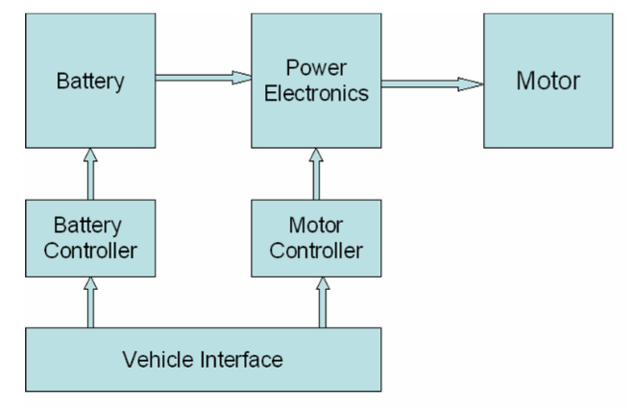The Vehicle Interface communicates with the Battery Controller and Motor Controller, and provides an interface with the vehicle-level controls and sensors. Communication between the separate units involves the use of a Controller Area Network (CAN) communications system.

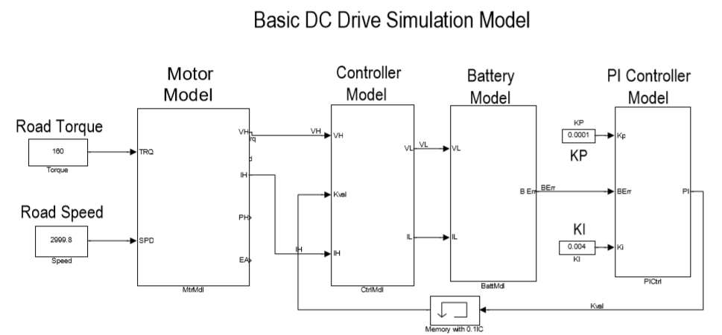

Battery Electric Vehicles (BEV) and Hybrid Electric Vehicles (HEV) frequently use special, high efficiency Permanent Magnet Synchronous Motors (PMSM). This type of motor may be referred to as a brushless DC motor. PMSM motors actually use AC voltage that is supplied by the Motor Controller. The motor voltage is frequently a 10-20 KHz Pulse Width Modulated AC voltage where the voltage and frequency are adjusted to provide the proper motor speed and magnetic field values.

A DC permanent magnet motor is not appropriate for BEV or HEV applications due to weight and efficiency considerations.

The model does not include power loss due to friction and other rotational losses of hysteresis, eddy current, and windage. The model also does not include the time lag due to energy storage in the rotor inertia. Friction and inertial were not specified in the model and are assumed equal to zero.

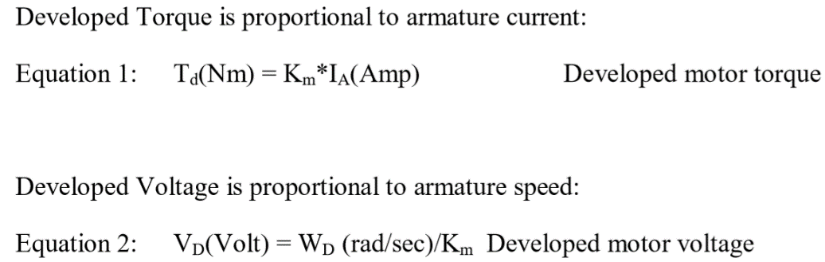

Motor armature input or terminal voltage is equal to the sum of developed voltage plus resistance and inductance voltage drops. In addition, the motor High Side voltage and current are directly connected to, and therefore identical to, the motor controller High Side voltage and current.

Shaft output torque is equal to developed torque minus friction loss (Bw) and inertial loss (J*dw(t)/dt).

The motor physical constant, K**m**, is a physical parameter that depends upon the construction of the motor. In the SI system K**m** has units of (Amp/Nm) or (Volt / (rad/sec)). At the electrical – mechanical interface inside the motor the developed electrical power (P = I**A**\* V**D**\* K**m**) is equal to the developed mechanical power (P = K**m**\* T**d**\* W**D**).

Current flows from anode to cathode while the conventional current is accepted to be the flow from cathode to anode.

**How a DC Motor Works:**

A metal bolt is not a magnet but it’s basically made up of magnetic domains that point in random directions. While constructing a coil, wrapping the metal bolt with wires (an electromagnet) and passing current through them makes these magnetic domains to line up. An electromagnet can be turned on and off unlike permanent magnets. The action of turning on and off while flipping the poles of an electromagnet is a basic analogy to explain how the electric motors work. If the metal bolt with wires is replaced with a metal loop (armature), and the permanent magnets are curved, we obtain an electric motor. The armature is a flat magnet which has poles: one at the bottom, one on the top, stacked together. However, to keep the armature spinning, the poles have to be flipped constantly. This action is done by a component called the commutator. The commutator is a ring with gaps in the opposite sides (2 parts). The commutator spins along with the armature and it touches brushes on each sides. These brushes have springs inside, so that they always touch the commutator. The current flows from the wire through the brush, the commutator ring, the armature loop and back through the other side. When the armature starts to turn, the commutator rings spins as well. When the gap in the middle of the ring is reached, the brushes that maintain contact, touch the other ring, flipping the direction of the current. This results in a continuous spinning motion as long as the power is on. Adding armatures to this system, allows the spinning to be continuous and consistent. The loops take turn to be an electromagnet. The compartment that holds the 2 permanent magnets which don’t move is called the stator. The armature is also called the rotor. The axle is the part that goes through the middle and then sticks out the back of the motor.

**Electric Motor Types**

**Brushed DC Motor:** A brushed DC motor uses a configuration of wound wire coils, the armature, acting as a two-pole-electromagnet. The current’s directionality is reversed twice per cycle by the commutator, a mechanical rotary switch. This facilitates flow of the current through the armature; thus, the electromagnet’s poles pull and push against the permanent magnets along the outside of the motor. The commutator the reverses the polarity of the armature’s electromagnet as its poles cross the permanent magnets’ poles.

**Advantages:** Low overall construction costs, can often be rebuilt to extend life, simple and inexpensive controller, controller not needed for fixed speed, ideal for extreme operating environments.

**Brushless DC Motor:** A brushless DC motor utilizes a permanent magnet as its external rotor. In addition, it uses three phases of driving coils and a specialized sensor (Hall-Effect Sensor) that tracks rotor position. As the sensor tracks the rotor position, it sends out reference signals to the controller. The controller, in turn, activates the coils in a structured way – one phase after the other.

**Advantages:** Less overall maintenance due to lack of brushes, operates effectively at all speeds with rated load, high efficiency and high output power to size ratio, reduced size with far superior thermal characteristics, higher speed range and lower electric noise generation. BLDC motors are more common than their brushed counterparts.

**Brushless AC Motor:** In AC induction motors, the rotor turns in response to the induction of a rotating magnetic field within the stator, as the current passes. Rather than including the rotor in a brushless DC motor, permanent magnets are bonded directly (synchronous) to the rotor, as the current passes through the stator, the poles on the rotor rotate in relation to the electromagnetic poles created within the stator, creating motion.

Efficiency: BLDC > BDC > AC

Size: AC > BDC > BLDC

**Servo Motor:** A servo motor is a closed-loop mechanism that incorporates positional feedback in order to control the angle, rotational or linear speed and position of the output shaft. It is comprised of several parts namely: a control circuit, servo motor, shaft, amplifier and either an encoder or resolver. This actuator is used to have a high efficiency/great precision motion control. It utilizes a regular motor and couples it with a sensor (a type of encoder built in the motor housing, usually fitted with the gear system) for positional feedback. The controller is the most important part of the servo motor designed and used specifically for this purpose.

**AC** (speed is determined by the frequency of the applied voltage and the number of magnetic poles, high repetition and high precision, will withstand higher currents, robotics applications) / **DC** (speed is directly proportional to the supply voltage with a constant load) (a DC motor, a position sensing device, a gear assembly and control circuit)

1. In order to control the motor speed; a potentiometer produces a voltage which is applied as one of the inputs to the error amplifier.
2. In some circuits, a control pulse is used to produce DC reference voltage corresponding to desired position or speed of the motor and it is applied to a pulse-width voltage converter. The length of the pulse decides the voltage applied at the error amplifier as a desired voltage to produce the desired speed or position.
3. For digital control, a PLC or other motion controller is used for generating the pulses in terms of duty cycles to produce more accurate control.
4. The feedback signal sensor is normally a potentiometer that produces a voltage corresponding to the absolute angle of the motor shaft through the gear mechanism. Then, the feedback voltage value is applied at the input of error comparator amplifier.
5. The amplifier compares the voltage generated from the current position of the motor resulting from the potentiometer feedback and to the desired position of the motor producing an error either of a positive or a negative voltage.
6. This error voltage is applied to the armature of the motor. As the error increases, so does the output voltage applied to the armature. As long as the error exists, the comparator amplifier amplifies the error voltage and correspondingly powers the armature.
7. The motor rotates until the error becomes zero.

**Brushed** (less expensive, simpler to operate) / **Brushless** (more reliable, less noisy, higher efficiency)

AC servo motors (mostly brushless) are generally categorized as the speed of the rotating synchronous/asynchronous field.

**Synchronous** (rotor rotates at the same speed as the stator’s rotating magnetic field, higher efficiency) **/Asynchronous** (rotor rotates at a slower speed than the stator’s rotating magnetic field, based on induction)

Servo motors are mostly AC brushless motors.

Universal motors (brushed) can run on AC/DC power.

**Stepper Motor:** A stepper motor is a brushless, synchronous electric motor that converts digital pulses into mechanical shaft rotation. Its normal shaft motion consists of discrete angular movements of essentially uniform magnitude when driven from sequentially switched DC power supply.

The stepper motor is a digital I/O device. It is particularly well-suited to the type of application where control signals appear as digital pulses rather than analog voltages. One digital pulse to a stepper motor drive or translator causes the motor to increment one precise angle of motion. As the digital pulses increase in frequency, the step movement changes into continuous rotation.